**Expt. No. :**  **2(a)** **EXCHANGE OF TWO VALUES**

**Date : 25-12-2022**

# PYTHON PROGRAMMING USING SIMPLE STATEMENTS AND EXPRESSIONS

**AIM:**

To draw flowchart, algorithm, and program for the given problem.

**ALGORITHM:**

|  |  |
| --- | --- |
| **Step 1** | **:** Start |
| **Step 2** | **:** read values of a and b |
| **Step 3** | **:** assign c=a |
| **Step 4** | **:** assign a=b |
| **Step 5** | **:** assign b=c |
| **Step 6** | **:** display a, b |
| **Step 7** | **:** Stop |

**PROGRAM:**

**# METHOD-1 USIGN THIRD VARIABLE:**

a=int(input('First value : ')) b=int(input('Second value : ')) c=a # using third variable a=b b=c

print(f'The exchanged values are a={a} and b={b}')

**OUTPUT:**

First value : 2

Second value : 3

The exchanged values are a=3 and b=2

# #METHOD-2 USIGN COMMA OPERATOR

x=int(input('First value : ')) y=int(input('Second value : ')) x,y=y,x # using comma operator print(f'The exchanged values are a={x} and b={y}')

**OUTPUT:**

First value : 2

Second value : 3

The exchanged values are a=3 and b=2

# #METHOD-3 USIGN ARITHMETIC OPERATOR

a=int(input('First value : ')) b=int(input('Second value : ')) a=a+b

b=a-b # using arithmetic operator a=a-b

print(f'The exchanged values are a={a} and b={b}')

**OUTPUT:**

First value : 10

Second value : 15

The exchanged values are a=15 and b=10

# #METHOD-4 USING XOR OPERATOR

a=int(input('First value : ')) b=int(input('Second value : ')) a=a^b

b=a^b # using XOR operator a=a^b

print(f'The exchanged values are a={a} and b={b}')

**OUTPUT:**

First value : 2

Second value : 3

The exchanged values are a=3 and b=2

**FLOWCHART:**

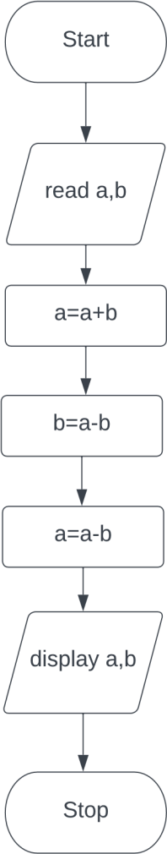

**Expt. No. : 2(B)** **CIRCULATING THE LIST OF VALUES**

**Date : 25-12-2022**

**ALGORITHM:**

|  |  |
| --- | --- |
| **Step 1** | **:** Start |
| **Step 2** | **:** read list a |
| **Step 3** | **:** display a |
| **Step 4** | **:** assign i=0, n=size of a |
| **Step 5** | **:** Check if i<n  **5.1:** If Yes, then a.append(a[0]), a.pop(0), i=i+1  **5.2:** display a and go to step 5  **5.3:** If No, then go to step 6 |
| **Step 6** | **:** Stop |

**PROGRAM:**

# # METHOD-1 USING IN BUILD FUNCTION

a=input('Enter values : ').split(',') print(f'The origianl list is {a}','\n','Circulating the list') for i in range(len(a)): a.append(a[0])

a.pop(0) # using Build_in function print(a)

**OUTPUT:**

Enter values : 1,2,3,4,5

The origianl list is ['1', '2', '3', '4', '5']

Circulating the list

['2', '3', '4', '5', '1']

['3', '4', '5', '1', '2']

['4', '5', '1', '2', '3']

['5', '1', '2', '3', '4']

['1', '2', '3', '4', '5']

# # METHOD-2 USING SLICING OPERATOR

a=input('Enter values : ').split(',')

print(f'The origianl list is {a}','\n','Circulating the list') for i in range(len(a)):

cir=a[1:]+[a[0]] # using slicing operator print(cir)

**OUTPUT:**

Enter values : 1,2,3,4,5

The origianl list is ['1', '2', '3', '4', '5']

Circulating the list

['2', '3', '4', '5', '1']

['2', '3', '4', '5', '1']

['2', '3', '4', '5', '1']

['2', '3', '4', '5', '1']

['2', '3', '4', '5', '1']

**FLOWCHART:**

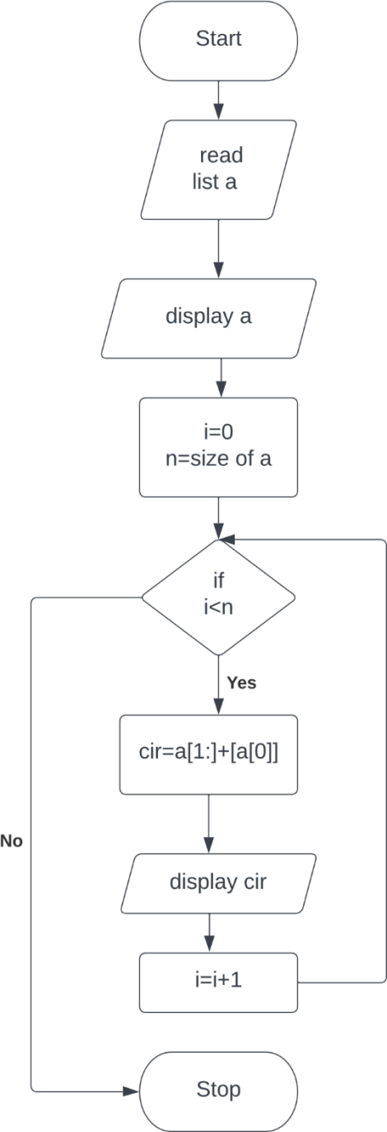

**Expt. No. : 2(C)** **CALCULATE THE DISTANCE BETWEEN TWO POINTS Date : 25-12-2022**

**ALGORITHM:**

|  |  |
| --- | --- |
| **Step 1** | **:** Start |
| **Step 2** | **:** read values of x1,x2, y1, y2 |
| **Step 3** | **:** import math |
| **Step 4** | **:** compute d= math.sqrt((x2-x1)**2+(y2-y1)**2) |
| **Step 5** | **:** display d |
| **Step 6** | **:** Stop |

**PROGRAM:**

import math x1=int(input('Enter x1 : ')) x2=int(input('Enter x2 : ')) y1=int(input('Enter y1 : ')) y2=int(input('Enter y2 : ')) d=math.sqrt((x2-x1)**2+(y2-y1)**2) print(f'The distance between two points is {d}')

**OUTPUT:**

Enter x1 : 3

Enter x2 : 7

Enter y1 : 2

Enter y2 : 8

The distance between two points is 7.211102550927978

**FLOWCHART:**

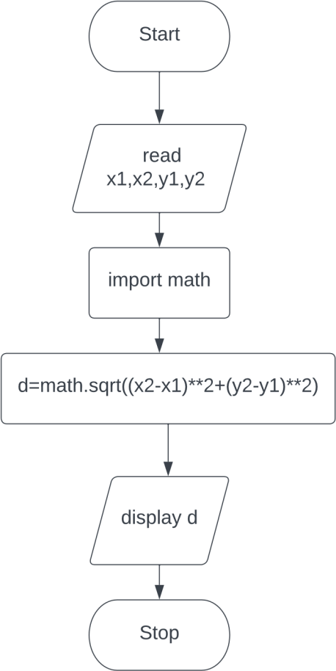

**Expt No : 2(d) FARENHEIT TO CELSIUS**

**Date. :25-12-2022**

**ALGORITHM:**

**Step 1 :** Start

**Step 2 :** Read Farenheit f

**Step 3 :** Compute c=(f-32)*(5/9)

**Step 4 :** Display celsius c

**Step 5 :** Stop